AMBIENTES
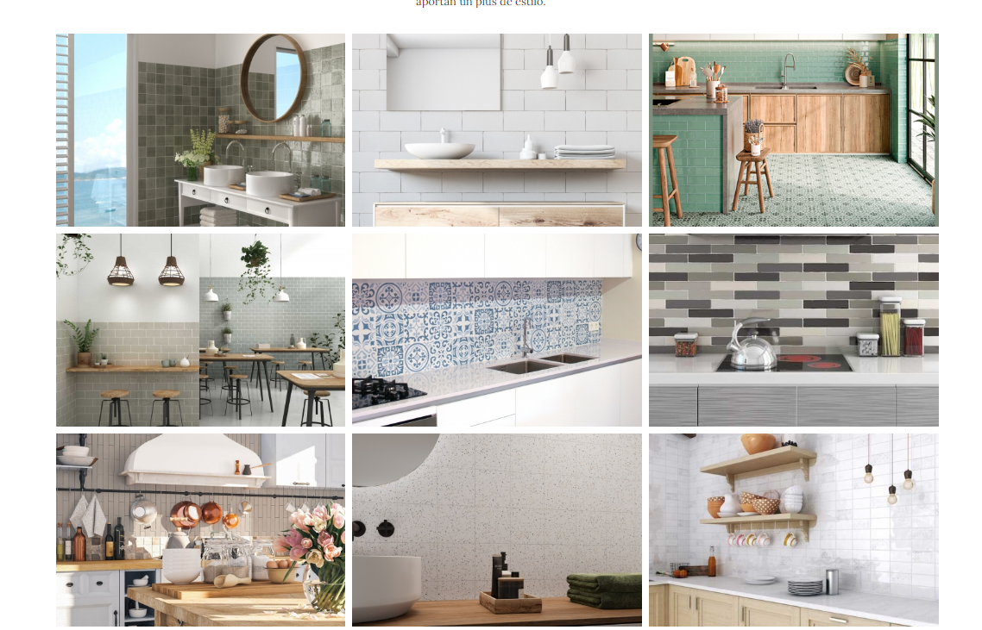

11.5X11.5 TANGER SHADOW MUSGO
10X20 YORKSHIRE SNOW WHITE
7.5X15 CAMBRIDGE JADE + 20X20 ANTIC STYLE JADE DECOR
10X20 YORKSHIRE AGUA+ 10X2 YORKSHIRE VINTAGE
20X20 MEDITERRANEO AZUL
5X25 OXFORD
5X25 OXFORD BISCUIT
13X13 SUGAR DROPS
7.5X15 BELLE EPOQUE

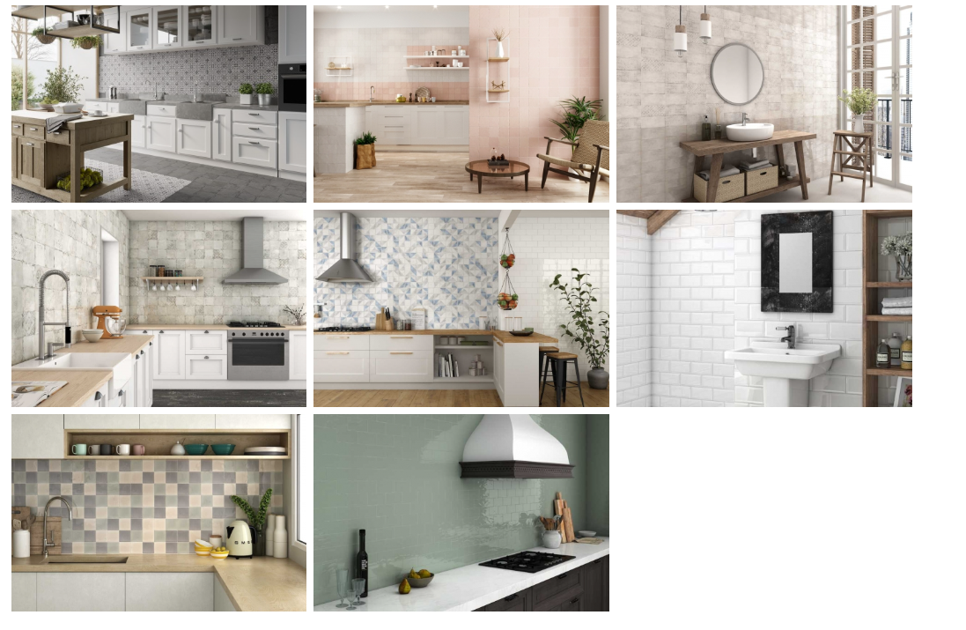

20X20 ANTIC STYLE GREY+20X20 ANTIC STYLE GREY DECOR
11.5X11.5 TANGER MATE CORAL
10X20 BELLE EPOQUE
15X15 PROVENZA
10X20 KUBIK
10X20 BISELADO BLANCO
10X10 VICTORIA
7.5X15 CAMBRIDGE JADE

